Practical: 6 | To implement the Coin Change problem using Dynamic Programming and find the number of ways to make a given target amount using the available coin denominations.
05/08/2026

Aim:
To implement the Coin Change problem using Dynamic Programming and find the number of ways to make a given target amount using the available coin denominations.

Algorithm:

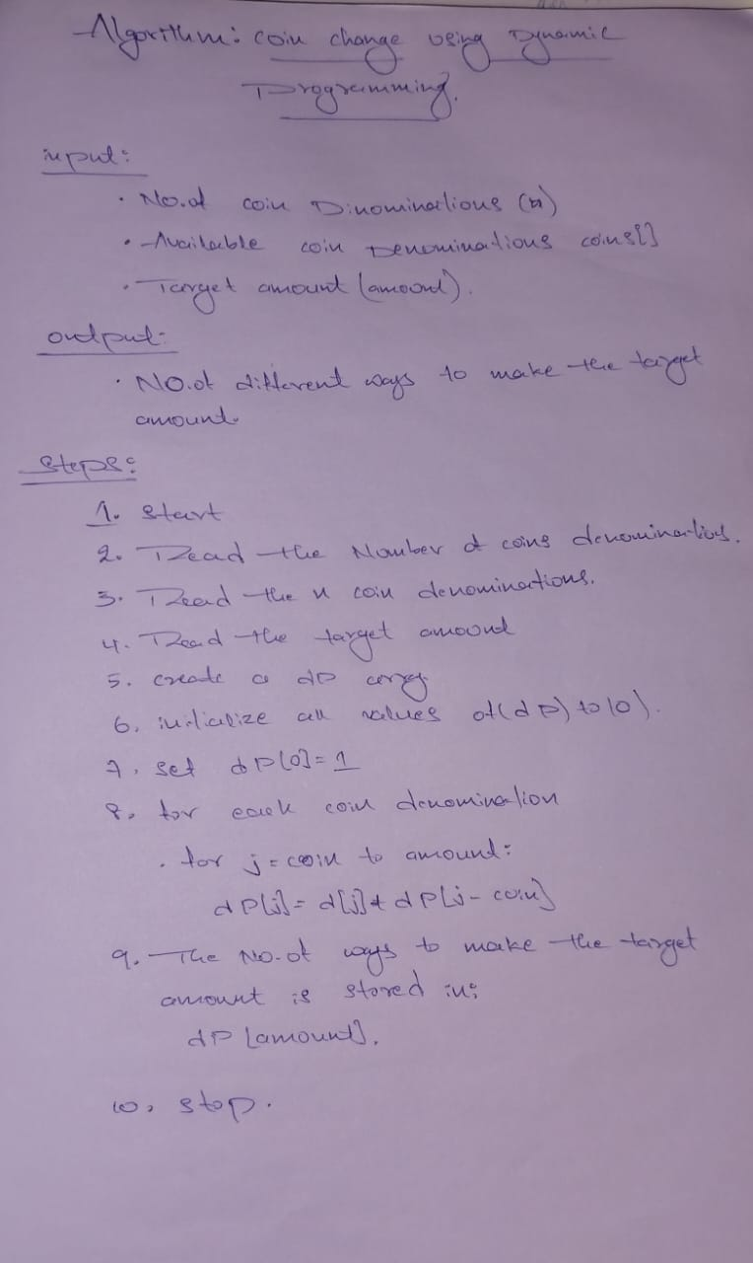

Program:

#include <iostream>
#include <vector>
using namespace std;

class CoinChangeWays {
private:
vector<int> coins;
int amount;

public:
void getInput() {
int n;

cout << "Enter number of coin types: ";
cin >> n;

coins.resize(n);

cout << "Enter coin denominations: ";
for (int i = 0; i < n; i++)
cin >> coins[i];

cout << "Enter target amount: ";
cin >> amount;
}

void solve() {
vector<long long> dp(amount + 1, 0);

dp[0] = 1; // Base case

for (int coin : coins) {
for (int i = coin; i <= amount; i++) {
dp[i] += dp[i - coin];
}
}

cout << "Number of ways = " << dp[amount] << endl;
}
};

int main() {
CoinChangeWays obj;

obj.getInput();
obj.solve();

return 0;
}

TIME COMPLEXITY:

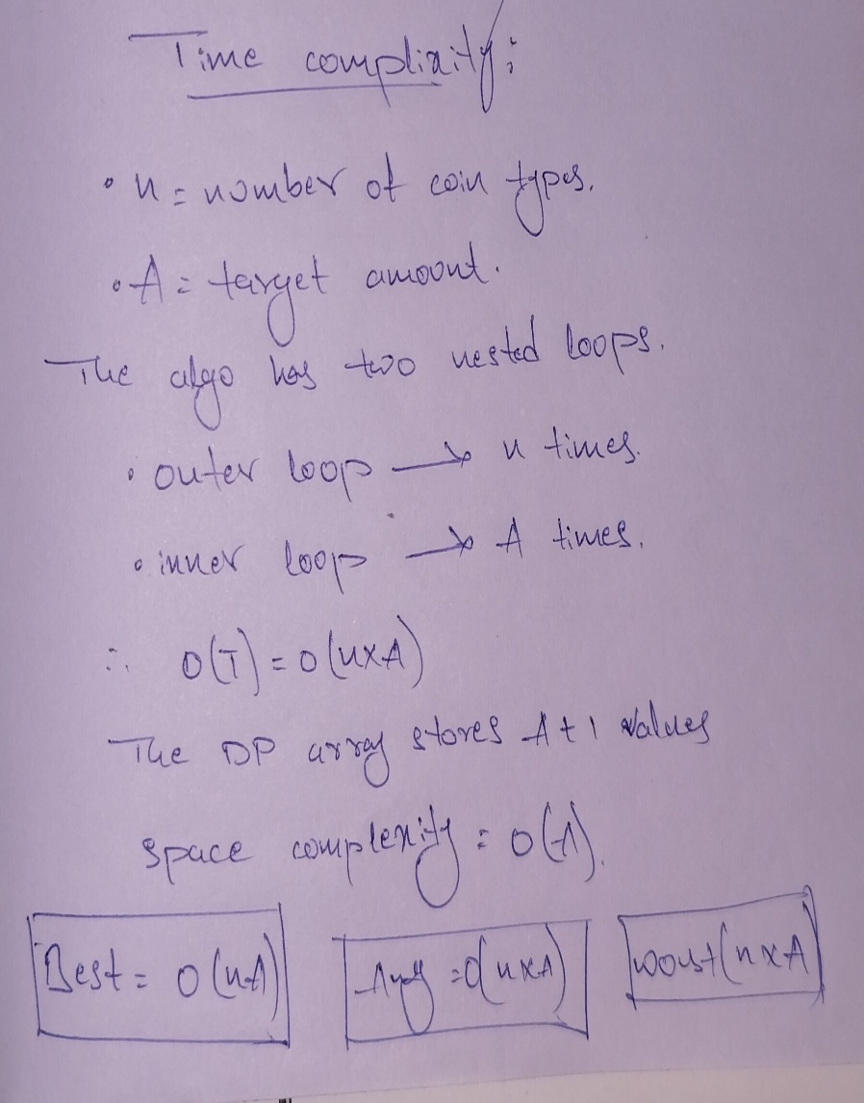

Output:

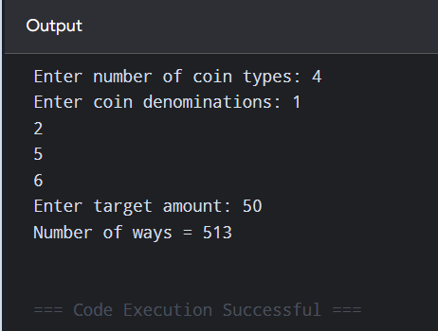

Conclusion:

The Coin Change problem was successfully implemented using Dynamic Programming. The algorithm efficiently calculates the number of ways to form the target amount using the given coin denominations with a time complexity of O(n × A) and space complexity of O(A).

